



*NCJET*

“Compete With The Elite”

YOUTH SCRATCH SPORT TOURNAMENT

# JR GOLD EVENT

**February 4, 2018**

AT

Gold Country Lanes, 81 Ridge Rd.,

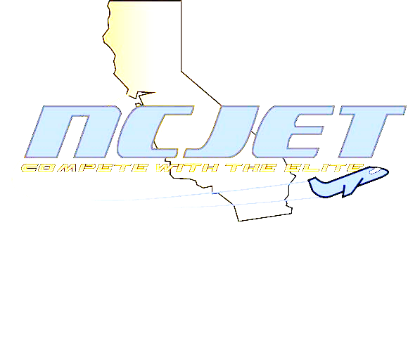Sutter Creek, CA - (209) 223-3334

# $2 Brackets

4 games of Qualifying on

Sport Pattern

Boys 190/up, 189/under

Girls 180/up, 179/under

Pinfall carries over

to match play

Top 3 Finalists bowl a stepladder

Sunday Check in at 9:00 a.m. – Start at 10:00 a.m.

ENTRY FEES $30.00 lineage est.*

$ 5.00 NCJET membership

 $15.00 prize fund

$50.00 Entry Fee

USBC Certified #5013 - Tournament Directors:

Debbie Haggerty (916) 663-5897 – [Debra.haggerty7@gmail.com](mailto:Debra.haggerty7@gmail.com)

Welby Spanton (916) 346-5917 – welby18@gmail.com

